**Final Notes**: Student will be required to save their “Change” (coins) all school year. This is to help students form early saving habits. Students will earn 20% of their current grade each marking period. The goal is $75.00, that’s $12.50 each marking period. See attached Savings Chart.

Students will also be asked to donate $2 to charity (optional), details will be sent home on the charity. The lesson is…give and watch it return back to you. Students will earn 20% of their current grade at the end of the school year.

Students are expected to have a note book for notes and other materials.

-----------------------------------------------------------------------

**\*\*PLEASE REVIEW THE DISTRICT POLICIES IN STUDENT HANDBOOK\*\***-

We have received and read the rules and expectations of room 204 Personal Finance. We agree to support and abide by the rules and expectations, including district policies.

____________________________________________

Parent/Guardian Signature

____________________________________________

Student Signature

**There is an extended PowerPoint version of the syllabus in Edmodo**

**~All rules and guidelines are subject to change at the teacher's discretion.**

**Rules/Expectations**

**Rules for Classroom Behavior**

* Students must know and follow all rules in the student handbook in addition to classroom rules mandated by the teacher.
* Be in your assigned seat and prepared to work when the final bell rings.
* Follow directions the first time given.
* No arguing/fighting in class.
* Abstain from eating, drinking, and grooming during class.
* No Electronic devices.
* Respect the rights and property of others.
* Be courteous to your teacher and your classmates.
* Clean your workstation before departure
* Bring materials and have them ready.
* Do not interrupt other students' learning.
* No vandalism. Don't write or carve on your desk or school property.
* Treat computers with care.
* HAVE FUN!

**Consequences for Disruptive Behavior**

**1st Offense:** A verbal warning will be given when a minor classroom or school rule is broken, unless the discipline code calls for a referral.

**2nd Offense:** A 2nd verbal warning and a telephone call to the parent/ guardian.

**3rd Offense:** A written referral to ISS/Behavior Specialist and a call home. If a conference is necessary, it will be scheduled through me (Mrs. Moore) or behavioral team.

**4th Offense:** A written referral to the main office or Behavioral Specialist.

**Policy for Severe Behavior:**

Severely disruptive behavior such as repeated disruptions, fighting, cursing, physical assault, or verbal abuse of the teacher will result in an immediate referral.

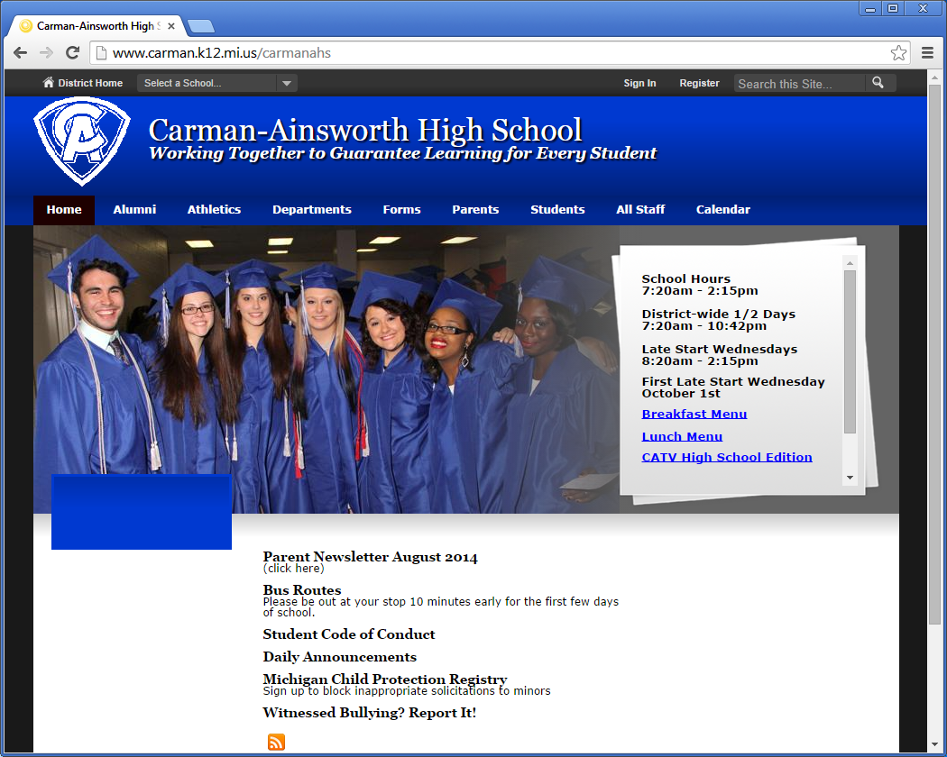

**Career and Technical Education**

**Personal Finance**

Instructor: Mrs. J. Moore

School: Carman-Ainsworth High School

Room: 204

Phone: 810-591-5572

Email address: [jmoore1@carmanainsworth.org](mailto:jmoore1@carmanainsworth.org) or [jmoore1426@gmail.com](mailto:jmoore1426@gmail.com)

**Personal Finance Course Rationale/Overview:**

The goal of Personal Finance is to help students to become financially responsible, conscientious members of society.  To reach that end, this course develops students understanding and skills in such areas as money management, budgeting, financial goal attainment, the wise use of credit, insurance, investments, and consumer rights and responsibilities.

This course will give students the tools and resources needed to make wise financial decisions.  Students will analyze their personal financial decisions, evaluate the costs and benefits of their decisions, recognize their rights and responsibilities as consumers, and apply the knowledge learned to financial situations encountered later in life.

**Personal Finance Course Description:**

Personal Finance is a year course designed to help students understand the impact of individual choices on occupational goals and future earnings potential.  Personal Finance students will experience real world scenarios and use strategies covered in the course to help them make sound financial decisions.  Students will design personal and household budgets; simulate use of checking and saving accounts; demonstrate knowledge of finance, debt, 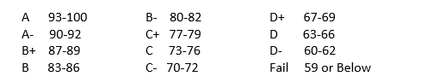and credit management; evaluate and understand insurance and taxes. This course will provide a foundational understanding for making informed personal financial decisions.

**Personal Finance Curriculum**

**Unit 1: Gross Pay**

**Unit 2: Net Pay**

**Unit 3: Banking**

**Unit 4: Credit Cards**

**Unit 5: Loans**

**Unit 6: Own a Home or a Car**

**Unit 7: Insurance and Investments**

**Unit 8: Budgets**

**Additional**

* Consumer Protection
* Credit Report
* Addictions (Gambling, Drugs, etc.)
* Child Support
* Garnishment

**Textbook/Instructional**

* Business Math, South-Western Cengage Learning; Mary Hansen 17th Edition
* Building Your Future, The Actuarial Foundation; Books 1-4
* Personal Finance Literacy, Thompson, South-Western; Joan Ryan, 2008

**Grading Policy**

* Final Exam will count for 20% of your final grade.
* If you reach your 12th absence you will be placed on a contract. If you do not abide by the contract you will be placed on Pass /Fail, and must pass the final exam with a 78% or better.
* If you’re in class and decide not to do your assignment. You will not be allowed to turn it in later.
* Late assignments will be marked down 20%
* Students may redo any assignments, test, and quizzes, but only once. Students will have 24 hours to redo an assignment from the day the graded assignments are returned to them. Test and Quizzes will be schedule for Thursday’s. **(This does not include the Final Exam.)**
* All assignments, readings and notes will be posted daily to Edmodo.com; so if you’re absent you are expected to keep-up using the Edmodo site. (Edmodo is a smartphone **App**)
* **You are** responsible for retrieving your missing assignments and making up test/quizzes**, NO EXCUSES OR EXCEPTIONS!!!**
* If you are failing the course or in danger of failing a letter will be sent to your parents.
* 5 Participation points awarded daily (25pts week)
* Course Rubric (Located in “Edmodo” under the tab “Folder”)
* Please make sure you have “Student View” I will not waste class time showing grades during class; however, I do provide progress reports twice a marking period. (I select when provided)
* Project Due Dates: Will not Change (on-time) NO EXCEPTIONS!

**Grading**

I will use the traditional point system to determine grades. Each assignment will be given a point value and what is earned will be calculated using a percent. The letter grades will be assigned as follows:

**Academic Integrity**

As stated in the Student Code of Conduct, the school may discipline a student for academic dishonesty which is defined as any activity that tends to undermine the academic integrity of the school. Academic dishonesty includes, but is not limited to: cheating, fabrication, interference, plagiarism, etc. Definitions, procedures, and sanctions for these violations may be found in the Student Code of conduct.

Students that are caught cheating off each other will receive a “Zero” NO EXCEPTIONS.

Server cheating (“hacking” into another student computer and taking their work) will be written up.

**NOCTI/CATEMA**

**CATEMA** system is an online student registration and tracking program. Career and Technology, Course Articulation, or any other educational programs can track their schools, teachers, students, courses, and credits.

**EVERFI** is an online pre/post assessment that each Personal Finance student will take. There are 9 segments to the assessment. If you pass all 9 post segments with a 70% or better, you will be exempt from the FINAL EXAM.

Students that complete CTE programs with an **80% or better**, can earn college credit called articulation credit at several Colleges/Univeristies throughout Genesee County (Mott, Baker, Davenport and U of M-Flint). Visit our website at: <https://www.carman.k12.mi.us/Page/4824> and <https://www.carman.k12.mi.us/Page/5747>

